Coweta County, Georgia

Regulatory Permit Application



**New Applications** All forms must be filled out completely, including mailing and business addresses and all available phone/fax/email information. Currently we do not accept applications by mail. ($75.00)

**Type of Business**

□ (1) Carnival □ (2) Taxicab/Limousine Operator □ (3) Tattoo Artist □ (4) Stable

□ (5) Shooting Gallery □ (6) Scrap Metal Processor □ (7) Pawnbroker □ (8) Food Service Establishment □ (9) Precious Metals Dealer □ (10) Peddler □ (11) Parking Lot □ (12) Nursing/Personal Care Home

□ (13) Newspaper Vending Boxes □ (14) Modeling Agency □ (15) Massage Parlor □ (16) Auto/Motorcycle Racing

□ (17) Boardinghouse □ (18) Businesses which provide appearance bonds □ (19) Boxing/Wrestler Promoter

□ (20) Hotel/Motel □ (21) Hypnotist □ (22) Handwriting Analyst □ (23) Health Club/Gym/Spa

□ (24) Fortuneteller □ (25) Escort Service □ (26) Burglar/Fire Alarm Installer □ (27) Locksmith

**The following must be checked off and included with the original, signed application:**

**□ Completed Application □ Quality Corridor Map (Peddler’s)**

**□ Copy of owner’s driver’s license □ Copy of current business license**

**□ Georgia Bureau of Investigation / Georgia Crime Information Center Consent Form**

**Copies of the following must be checked off and provided if applicable to the license being issued:**

□ State License (if required by the State of Georgia) Health Inspection Certificate (Health Dept. 770-254-7422)

□ Incorporation Letter Dept. of Agriculture Inspection (404-656-3645)

**Contact Information:**

Business License Information Joy Thompson 770-254-2626

Community Development Teresa Crow / Ben Sewell 770-254-2635

**Regulatory Application**

|  |  |  |  |
| --- | --- | --- | --- |
| Please Fill In All Information COMPLETELY CALENDAR YEAR ___________________  Please Type or Print With Ball Point Pen PENALTY FOR FAILURE TO FILE RENEWAL BY APRIL 15th EACH YEAR | | | |
| BUSINESS NAME: | | | BUSINESS LOCATION STREET ADDRESS and ZIPCODE **(Not PO Box)** | | | BUSINESS DESCRIPTION: |
| **MAILING/CONTACT** INFORMATION  FOR BUSINESS | ATTENTION: | | BUSINESS MAILING ADDRESS, CITY, STATE, ZIPCODE (if different) | | | BUSINESS PHONE # |
| ADDITIONAL  CONTACT | BUSINESS FAX # | | BUSINESS WEB ADDRESS | | | EMAIL |
| LICENSEE TYPE:  CHECK ONE | _____PARTNERSHIP  _____SOLE OWNER  _____ INC  _____ LLC  _____ OTHER |  | PRINCIPAL OFFICE AND CORPORATE NAME | | STREET OR PO BOX | CITY, STATE, ZIPCODE |
| . | FULL NAME | | STREET | | CITY | STATE, ZIPCODE |
| DRIVERS LICENSE NUMBER | | RACE | | SEX | DATE OF BIRTH |
| BUSINESS LICENSE NUMBER | | ISSUED BY | | EXPIRES | NAICS CODE |

In Accordance with the business ordinance, Coweta County, Georgia, I, the undersigned, certify that I am the person duly authorized by the business herein named to file this return, including the accompanying schedules and that the information contained in these documents are true, correct and complete. I hereby make application for an Occupational Tax Certificate to conduct the above-described business in the County. I understand that approval must be obtained from the departments having the authority prior to issuance of the certificate. By signature below, I do solemnly swear, subject to criminal penalties for false swearing, that information contained in the application is true and no false or fraudulent information is made herein to procure the granting of this certificate.

Owner’s Signature Date: ______________________________________

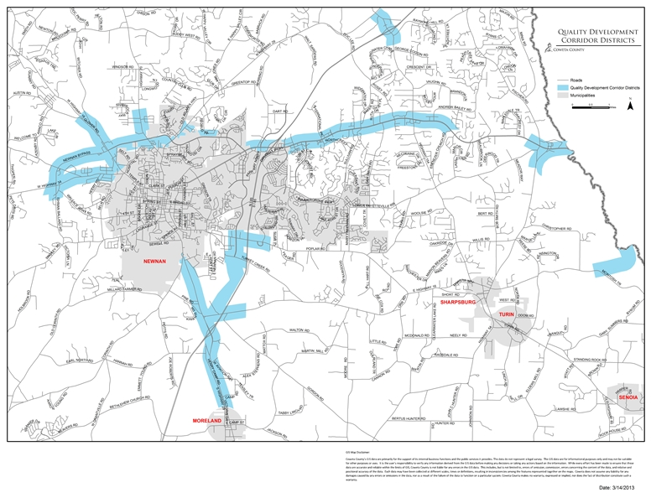

**I understand the guidelines of the Quality Corridor and have received a copy of the above map.**

Signature Date

**Georgia Bureau of Investigation**

**Georgia Crime Information Center**

**Consent Form**

I hereby authorize **Joy Thompson / Coweta County Business Tax Department** to receive any Georgia criminal history record information pertaining to me which may be in the files of any state or local criminal justice agency in Georgia.

LAST FIRST MIDDLE MAIDEN

ADDRESS CITY STATE ZIP CODE

/ /

SEX RACE DATE OF BIRTH SOCIAL SECURITY NUMBER

SIGNATURE DATE

**________________________________**

BUSINESS NAME REASON

- - - - - - - - - - - - - - - - - - - - - - - - - - - - - - - - - - - - - - - - - - - - - - - - - - - - - - - - - - - - - - - - - - - - - - - - - -

**Special employment provisions** (check if applicable - separate form must be submitted for each code)

* Employment with mentally disabled (Purpose code ‘M’)
* Employment with elder care (Purpose code ‘N’)
* Employment with children (Purpose code ‘W’)

**One of the following must be checked:**

🗸 This authorization is valid for 180 days from date of signature.

□ I, , give consent to the above named to perform periodic criminal history background checks for the duration of my employment with this company. (The requesting company and/or person will be charged each time the background check is completed.)

NOTARY SEAL /

Notary Signature Date